A GNN-Augmented Framework for Semantic Integrity Validation and Grounded Reasoning in Professional Knowledge Systems

A Capstone Project
Presented to the faculty of the Department of Software Engineering
Central Philippine University
Jaro, Iloilo City, Philippines

In partial fulfillment
Of the requirements for the Degree of
Bachelor of Science in Software Engineering

By
Samilo, Franz Eliezer E.
March 2026

Abstract
Professional knowledge synthesis faces a dual crisis: manual review is statistically unreliable (85% error rates in systematic reviews), while generative AI hallucinates. This study proposes a "Validate-then-Generate" architecture that inserts a CompGCN-based integrity layer between retrieval and synthesis. The system (1) ingests PDFs into a knowledge graph, (2) assigns plausibility scores to every relationship via link prediction, (3) filters retrieved triplets by score before passing them to the LLM, and (4) exposes provenance (source documents, cross-document links) in an audit trail. Evaluation targets: AUC-ROC > 0.95, MRR > 0.95, Grounding > 98%. A prototype demonstrates the feasibility of the approach for high-stakes domains such as legal research.
Keywords: Knowledge Graph, Graph Neural Network, CompGCN, Semantic Integrity, Retrieval-Augmented Generation, Hallucination, Plausibility Scoring, Provenance, Auditable AI.

Chapter 1: Introduction

1.1 Background and Rationale
The domain of high-stakes professional knowledge work that involves volumetric data and complex investigative analysis has entered a precarious state of "Information Ambiguity." In this contemporary landscape, the synthesis of information is no longer a straightforward task of aggregation but a forensic challenge of verification. Practitioners in these fields—legal researchers, meta-analysts, medical evidence synthesizers, and policy analysts—where factual precision is the primary currency, find themselves trapped in a "Professional Deadlock." This crisis is characterized by the simultaneous collapse of traditional manual review processes, which are buckling under the sheer volume of data, and the inherent unreliability of existing generative artificial intelligence (AI) architectures, which prioritize fluency over factual accountability.
The proliferation of digital literature has created an unprecedented data velocity. A single domain may produce thousands of peer-reviewed papers, legal precedents, or regulatory documents annually. Human reviewers cannot process this volume without sacrificing accuracy; the result is a trade-off between comprehensiveness and correctness. At the same time, Large Language Models (LLMs) have emerged as powerful tools for text generation, but they lack an internal mechanism to verify facts. When asked to synthesize information, they may produce plausible-sounding but entirely fabricated citations—a phenomenon known as "hallucination." The magnitude of this crisis is underscored by recent metrics in scientific publishing that signal a systemic failure in the peer-review and manual verification pipeline. In 2023, the academic community witnessed a shattering of the "trust ceiling" when Retraction Watch reported that more than 10,000 research papers were retracted in a single year, a new global record. This surge was not merely a statistical anomaly but a symptom of the industrialization of "paper mills" and "semantic fraud," confirming that the corpus of professional literature is no longer a pristine sanctuary of truth but a contested battlespace of verifiable and fabricated claims. The retraction of over 8,000 papers from Hindawi journals alone highlighted how systemic vulnerabilities in manual review processes could be exploited at scale.
Simultaneously, the severity of the AI hallucination threat compelled the editorial board of Nature to issue a landmark policy in 2023, explicitly banning AI tools from being listed as authors on research papers. The rationale was rooted in the fundamental principle of scientific accountability: "an attribution of authorship carries with it accountability for the work, which cannot be effectively applied to LLMs."
The convergence of these two failures creates a critical gap in the professional knowledge ecosystem. The deadlock presents a binary choice between two unacceptable options: the prohibitive inefficiecancy of manual verification and the inherent untrustworthiness of stochastic generation. This phenomenon is defined by a "Dual Deficit" that threatens the integrity of the professional record:
- The Manual Integrity Deficit: The empirically proven failure of human operators to accurately extract and synthesize data from massive datasets due to cognitive fatigue and the limitations of linear tools (e.g., spreadsheets).
- The AI Trust Deficit: The architectural inability of LLMs to distinguish between a statistically likely token sequence and an epistemic truth, resulting in "hallucinations" that pollute the knowledge base.
To resolve this, this research proposes a foundational experimental study designed to validate a novel "Validate-then-Generate" architecture. By inserting a structural auditing layer—specifically the Composition-based Multi-Relational Graph Convolutional Network (CompGCN)—the system shifts the role of artificial intelligence from an unaccountable author to a deterministic "digital detective." This framework addresses the "Corrupted Source Fallacy," wherein standard Retrieval-Augmented Generation (RAG) systems blindly retrieve and amplify existing errors in source material.

1.2 Statement of the Problem
The core problem this study addresses is the architectural inability of current knowledge synthesis systems to validate semantic integrity before generation. While tools exist for search (Google) and generation (ChatGPT), there is no integrated framework that mathematically validates the structural consistency of a professional knowledge base. Specifically, this study addresses four critical gaps identified in the intersection of Data Science and Professional Ethics:

1.2.1 The Manual Efficiency ("The Data Review Backlog")
The volume of professional literature has radically outpaced human cognitive capacity, creating a "Data Review Backlog" that stifles progress. Historical benchmarks established by Borah et al. (2017) indicate that a single systematic review requires a mean duration of 67.3 weeks to complete. This latency creates a temporal disconnect where scientific consensus lags years behind primary research. Critically, recent experimental data by Guo et al. (2025) suggests that this is not merely a speed issue but a capability ceiling; in structured extraction tasks, AI agents achieved 93.1% accuracy compared to a plateau of 79.7% for human reviewers.

1.2.2 The Manual Integrity ("The Unreliable Ground Truth")
Professionals lack a mechanism to validate the internal consistency of their source data, leading to an "Unreliable Ground Truth." Research by Gøtzsche et al. (2007) initially revealed that 63% of manual meta-analyses contained data extraction errors. Recent high-impact studies by Xu et al. (2022) confirm that this trend has accelerated, with error rates surging to 85.1% in systematic reviews. Furthermore, the prevalence of linear tools—where 65% of professionals rely on spreadsheets to manage graph-based data—exacerbates these errors by forcing high-dimensional data into low-dimensional formats.

1.2.3 The "Corrupted Source" Fallacy in RAG Architectures
This is a critical technical failure of existing Retrieval-Augmented Generation (RAG) systems. Standard RAG operates on an optimistic assumption: if a document is retrieved from a database, it is inherently true. However, given the evidence of 85.1% error rates in manual sources, standard RAG systems effectively retrieve and amplify human errors, creating a feedback loop of misinformation. Recent benchmarks by Barry et al. (2025) demonstrate that integrating graph-based structural verification can reduce hallucination rates by 6% compared to standard vector-based RAG.

1.2.4 Absence of "Semantic Fraud" Detection
While Graph Neural Networks (GNNs) are successfully used to detect financial fraud rings by identifying circular transaction loops (Liu et al., 2024), there is a significant lack of applied research utilizing GNNs to detect "semantic fraud." In professional literature, errors often manifest as structural anomalies such as circular reasoning, phantom citations (Athaluri et al., 2023), or conflicting witness narratives. The capability to mathematically identify a "citation ring" or a logical contradiction based on graph topology remains an underdeveloped frontier in Natural Language Processing.

1.3 Research Hypotheses
To address these gaps, this study posits the following hypotheses to be tested via experimental validation:
H1 (The Topological Correlation Hypothesis):
Semantic inconsistencies (e.g., contradictions, hallucinations, or extraction errors) in a knowledge graph manifest as detectable structural anomalies within the graph topology (e.g., broken transitivity, low-plausibility edge compositions).
H2 (The GNN Auditing Hypothesis):
A Composition-based Multi-Relational Graph Convolutional Network (CompGCN) can learn the "algebra of truth" (composition rules) of a professional domain sufficiently to assign low plausibility scores to anomalous edges, achieving an AUC-ROC > 0.95 and MRR > 0.95 in link prediction tasks.
H3 (The Grounding Hypothesis):
Restricting a Generative AI model to synthesize answers only from a GNN-validated subgraph (where anomalous edges are filtered) will result in a Grounding Score > 98%, effectively eliminating "phantom citations" and hallucinations from the output.

1.4 Specific Objectives
The primary objective of this research is to develop and validate a "Trustworthy Synthesis Platform" that prioritizes integrity over fluency. The specific operational objectives are:
- Automate Relationship Mapping (Knowledge Ingestion): To design an ingestion module capable of processing unstructured professional literature (PDFs), utilizing Natural Language Processing (NLP) to extract entities and latent semantic relationships to construct a raw Knowledge Graph. The system employs the SimpleKGPipeline from neo4j-graphrag, which performs schema-guided extraction via a large language model (Gemini) to populate a property graph with ontological node types (Entity, Method, Researcher, Dataset) and relationship types (USES, CONTRADICTS, EXTENDS).
- Proactive Conflict Detection (Addressing Manual Integrity & Semantic Fraud): To implement a Graph Neural Network, specifically the CompGCN architecture, to mathematically audit the graph topology. This involves assigning "Plausibility Scores" to edge connections via the DistMult composition operator to identify and flag semantic anomalies, contradictions, and "phantom" links.
- Grounded Generation (Addressing the Corrupted Source Fallacy): To implement a Grounded Generation engine that filters retrieved triplets by GNN plausibility scores () and synthesizes answers exclusively from validated subgraphs. The hybrid GraphRetriever combines vector similarity for seed selection with graph expansion for context. When no validated triplets exist, the system returns a hard "Grounding Error" rather than hallucinating.

1.5 Significance of the Study
The successful development of this framework offers transformative value across several high-stakes domains, shifting the paradigm from "Generative AI" to "Auditable AI."
This study contributes to a validated blueprint for "Trustworthy AI." It demonstrates that Graph Neural Networks can function as a "Superego" to the Large Language Model's "Id," forcing the probabilistic, creative nature of the LLM to adhere to the deterministic, verified structure of the Knowledge Graph. This supports the transition of AI from a creative assistant to a reliable professional agent—catching patterns that would be missed by fatigued human analysts.

1.6 Scope and Delimitations
Scope: The technical scope includes the implementation of PyTorch Geometric (CompGCN) for validation, a FastAPI backend with local hybrid retrieval and generator-side integrity filtering for grounded synthesis, and an optional Neo4j Aura Agent for cloud deployment.

Delimitations:
- Source Material: The system processes text-based PDFs. Images, complex LaTeX formulas, and tables are excluded from the current extraction pipeline to focus on semantic text relationships.
- Language: The NLP extraction modules are optimized for English-language documents; multilingual support is outside the scope of this experimental validation.
- Epistemic Limits: The system validates Internal Consistency (Plausibility), not Objective Universal Truth. It detects if a document contradicts other documents within the provided dataset or violates the structural logic of the graph. It does not cross-reference claims against the entire internet in real-time.
- Deployment: The prototype is designed for server-side deployment to handle the computational load of the graph database (Neo4j) and GNN inference (PyTorch Geometric); it is not designed for local mobile deployment.

1.7 Conceptual Framework
Figure 1.1 presents the conceptual framework that connects the problem statement to the proposed solution. The framework illustrates how the Dual Deficit (Manual Integrity Deficit and AI Trust Deficit) feeds into the Corrupted Source Fallacy of standard RAG, and how the Validate-then-Generate architecture intervenes by inserting a GNN-based integrity layer before synthesis.
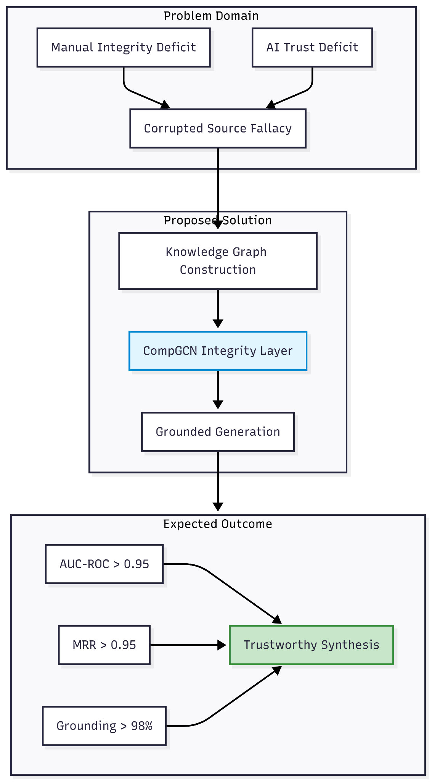

Chapter 2: Literature Review and Technical Justification

2.1 The Manual Integrity Deficit: A Statistical Autopsy of Human Failure
The transition toward automated synthesis is often framed largely as a matter of efficiency, a way to process more data in less time. However, a deep review of the literature reveals a more fundamental crisis of integrity. Manual human review, long considered the "gold standard" for evidentiary synthesis, is undergoing a systemic collapse under the weight of data volume.

2.1.1 The Baseline of Failure (2007-2022)
Historical data from the early 21st century provided the first indications of this collapse. A seminal review conducted by Gøtzsche et al. (2007) analyzed 27 meta-analyses and revealed that 63% contained significant data extraction errors. Critically, 70% of these errors were severe enough to negate or reverse the findings of the study.
Recent high-impact studies confirm that this trend has accelerated. Research by Xu et al. (2022), analyzing 201 systematic reviews, found that the error rate has surged to 85.1%, with errors present in 66.8% of all analyzed meta-analyses. The implications of these findings are catastrophic for evidence-based practice; reliance on manual review is no longer a guarantee of accuracy but a statistical probability of error.
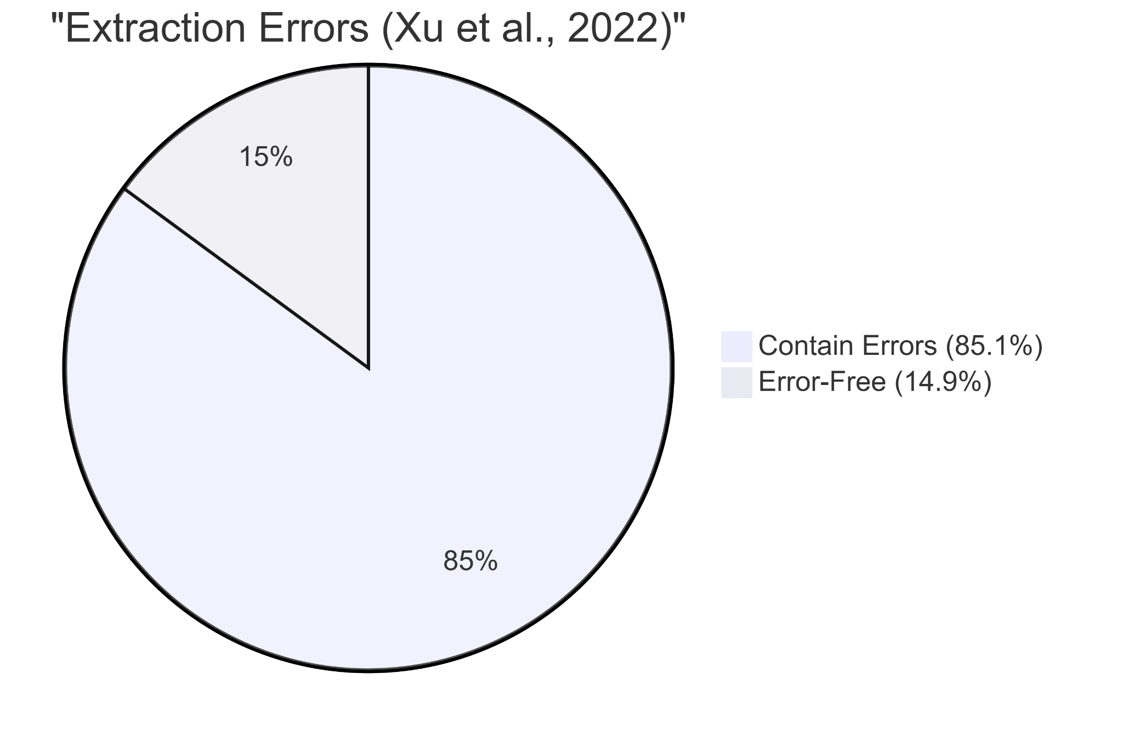

2.1.2 The "Human Bottleneck" and AI Superiority (2025)
The disparity between human capacity and data velocity defines the "Human Bottleneck." Borah et al. (2017) established that the mean time for a human team to complete a systematic review is 67.3 weeks. In contrast, recent benchmarks by Guo et al. (2025) comparing human vs. AI agent performance indicate that manual human extraction accuracy has plateaued at approximately 79.7%. In the same study, state-of-the-art AI agents achieved 93.1% accuracy in structured extraction tasks.

2.1.3 The Industrialization of Semantic Fraud
The manual integrity deficit is compounded by the active pollution of the scientific record. In December 2023, the journal Nature reported that over 10,000 research papers had been retracted that year, a record high. This surge was largely driven by "paper mills," commercial entities that produce fabricated research for profit. The Hindawi case, where publisher Wiley was forced to retract over 8,000 papers due to compromised peer review processes, illustrates the scale of the problem. These fraudulent papers often contain "tortured phrases" and circular citations that manual reviewers, overwhelmed by volume, fail to catch. The existence of such widespread fraud necessitates an automated, topological approach to detection.

2.2 The Artificial Intelligence Trust Deficit: The Hallucination Mandate
While AI offers a solution to the efficiency gap, it introduces the "Accountability Gap." Large Language Models (LLMs) function as probabilistic engines that predict the next likely token based on statistical patterns rather than verifying facts against an epistemic ground truth.

2.2.1 "Ghosts at the Gate": The Legal Crisis
In the legal sector, this deficit manifests as "phantom cases." Professor Christina Frohock (2025) documents instances where attorneys have been sanctioned thousands of dollars under Federal Rule of Civil Procedure 11 for citing judicial opinions fabricated entirely by AI. She describes these hallucinations as "ghosts at the gate," warning that if they are not actively filtered, they may take on a life of their own through repetition and reliance—a phenomenon she likens to the phantom town of "Agloe, New York," which appeared on paper maps as a copyright trap and eventually became a real-life location due to human error.

2.2.2 The Academic Crisis: Phantom Citations
In academic research, Athaluri et al. (2023) documented the propagation of "phantom citations"—references generated by ChatGPT that attribute real findings to non-existent papers. This pollution of the scientific record led the editorial board of Nature (2023) to ban AI from authorship, citing the inability to apply accountability to LLMs.

2.3 The "Corrupted Source Fallacy" in Retrieval-Augmented Generation
The current industry standard for mitigating hallucination is Retrieval-Augmented Generation (RAG). However, this research identifies a critical flaw in standard RAG: the "Corrupted Source Fallacy."
- Premise: Standard RAG assumes that if a document is retrieved from a database, it is inherently true.
- Reality: As proven by Xu et al. (2022), 85.1% of source documents (systematic reviews) contain data extraction errors.
- Result: Standard RAG blindly retrieves and amplifies these errors, creating a feedback loop of misinformation. It lacks an "Integrity Layer" to mathematically audit the plausibility of the retrieved information before generation.
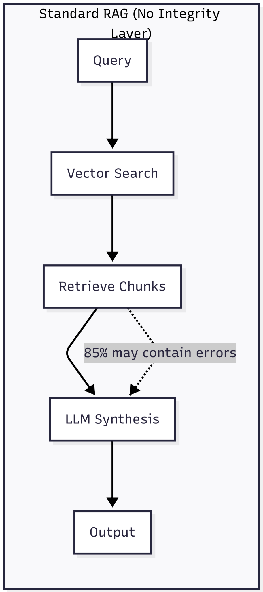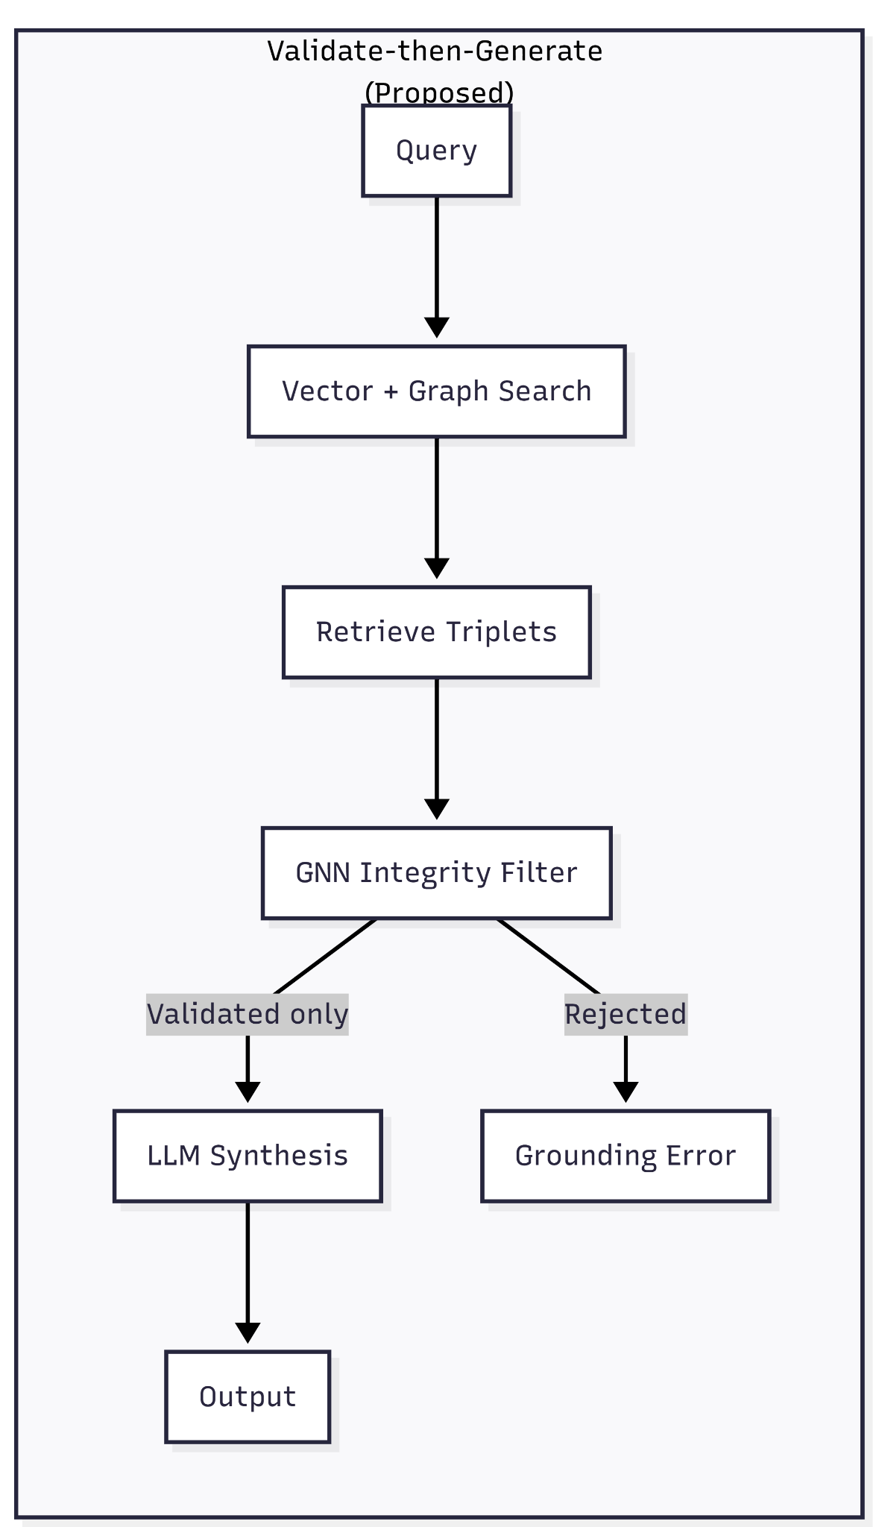

Dimension | Standard RAG | Validate-then-Generate
Retrieval Unit | Text chunks | Graph triplets (source, relation, target)
Integrity Check | None | CompGCN plausibility score ()
Failure Mode | Hallucination | Hard Grounding Error
Provenance | Document-level or none | Per-triplet source validation

2.4 The Tangent Argument: GNNs as Structural Detectives
To solve the integrity deficit, this research draws a "Tangent Argument" from the domain of financial fraud detection, applying its principles to semantic analysis.

2.4.1 Analogy of Financial Fraud Rings
In financial networks, fraud is often defined not by the content of a single transaction, but by the suspicious topology of connections. Liu et al. (2024) demonstrate that Graph Neural Networks (GNNs) are uniquely effective at detecting "coordinated ring fraud," characterized by circular transactions used to hide the movement of assets. This research posits a structural parallel: a semantic contradiction or citation error often manifests as a "semantic fraud ring." For example, a circular citation chain where Paper A cites Paper B, and Paper B cites Paper A, with no external grounding, creates a self-reinforcing loop of unverified truth. By treating knowledge graphs as transaction networks, the GNN can identify these structural loops as anomalies.

2.4.2 Contextual Verification in Fake News
Phan et al. (2023) found that GNN-based approaches outperform traditional models in fake news detection because they analyze "social context"—how a piece of information propagates through a network. In the professional domain, "citation context" acts as a proxy for verification. If a claim lacks supporting edges from reputable precedents, the GNN identifies it as a potential hallucination.

2.5 Technical Justification: CompGCN vs. R-GCN
The selection of the Composition-based Multi-Relational Graph Convolutional Network (CompGCN) is driven by the specific requirements of professional knowledge graphs.

2.5.1 Limitations of R-GCN
Traditional Relational Graph Convolutional Networks (R-GCN) struggle when handling complex professional data because they treat every type of relationship as a completely separate task. Imagine a student trying to learn a distinct set of grammar rules for every single verb in a language; eventually, there are too many rules to memorize, and the student becomes overwhelmed. Similarly, as the number of unique relationships in a dataset grows (e.g., "cites," "disputes," "extends," "overturns"), R-GCNs become inefficient and require too much computational power to function effectively (Vashishth et al., 2020).

2.5.2 The Superiority of CompGCN
CompGCN solves this problem by treating relationships as meaningful concepts rather than just labels. Instead of learning separate rules for everything, CompGCN learns how to combine the "starting point" (e.g., Paper A) with the "relationship" (e.g., contradicts) to predict the "destination" (e.g., Paper B). This allows the model to understand the "algebra of truth."
The standard layer propagation rule is:
Where:
- is the updated embedding for node .
- represents the set of neighbors of node .
- is the initial feature (embedding) for the neighbor node .
- is the initial feature (embedding) for the relation .
- 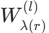 is a direction-specific weight matrix.
- is the composition operation.

Why DistMult? This study utilizes the DistMult composition operator, defined as the element-wise multiplication of the entity and relation vectors:
This operator allows the model to learn the semantic weight of the edge itself. If the model learns that "Author A" is highly trusted, and the relation "contradicts," the resulting composition will project into a vector space representing "untrustworthy."

2.6 Hybrid Retrieval and Global Sensemaking
For the generation phase, the system implements a custom hybrid retrieval pipeline. Unlike vector RAG, which retrieves text chunks based on semantic similarity alone, the pipeline combines (1) vector similarity for seed selection, (2) graph expansion for multi-hop context, and (3) optional Leiden-based community detection for discovery leads.
The Leiden algorithm is crucial because it guarantees well-connected communities, addressing a flaw in the older Louvain algorithm. It optimizes modularity (), a metric that measures the density of links inside communities compared to links between communities. The modularity equation, incorporating a resolution parameter , is defined as:
Where is the actual number of edges in community , is the total number of edges, is the sum of degrees, and is the resolution parameter. This hierarchical clustering allows the system to perform "Global Sensemaking." The study runs community detection only on the GNN-validated subgraph, ensuring that discovery leads are free from "phantom" data.

2.7 Generator-Side Integrity Filtering and Optional Aura Agent
Standard RAG architectures mitigate hallucination by retrieving text chunks based on semantic similarity. However, this "local search" approach is fundamentally ill-equipped for complex professional synthesis. It retrieves isolated fragments of text but fails to capture the latent structural relationships—the "multi-hop" context—between those fragments.
"The Remembrance" implements a hybrid retrieval pipeline. The DiscoveryGenerator filters retrieved triplets by audit_status or plausibility_score (default ). Only validated triplets are passed to the synthesis layer. If no validated triplets exist, the system returns a hard "Grounding Error," refusing to hallucinate. Rather than enforcing this at the Cypher level, generator-side filtering allows the local retriever to fetch full context while ensuring the LLM receives only GNN-validated triplets, effectively constraining the probabilistic nature of the LLM by the deterministic structure of the Knowledge Graph.

Chapter 3: Methodology

3.1 Research Design
This study employs a Developmental Research Design within an Experimental Framework. It focuses on the systematic translation of theoretical constructs, specifically Graph Neural Networks (GNNs) and Graph Retrieval-Augmented Generation (GraphRAG) into a functional prototype. The research follows an Agile-Iterative lifecycle. Given the complexity of tuning GNN hyperparameters (such as the Plausibility Threshold and the Leiden resolution parameter) and integrating multiple AI models, a linear Waterfall model is unsuitable. The study is a "Technical Validation" experiment; success is defined by technical Key Performance Indicators (KPIs) rather than user acquisition or commercial viability.

3.2 System Architecture: The "Validate-then-Generate" Pipeline
The workflow is governed by a strict unidirectional pipeline designed to prevent the "Corrupted Source Fallacy".
- Phase I: Ingestion and Graph Construction (The Builder): The ingestion module processes unstructured professional literature using the neo4j-graphrag SimpleKGPipeline. To handle the GNN "Cold Start Problem," DistilBERT generates 768-dimensional L2-normalized semantic vectors from node text, establishing initial features.
- Phase II: Semantic Integrity Validation (The Audit): The GNN projects nodes and relations into vector space using the DistMult operator. The model assigns a scalar Plausibility Score from 0.0 to 1.0 to every edge. Training uses Adam, ReduceLROnPlateau, and early stopping.
- Phase III: Grounded Generation (The Synthesis): The validated graph is queried. The DiscoveryGenerator filters triplets by plausibility scores. The "Detective Board" UI component exposes the evidence trail—validated triplets with source_docs and target_docs—enabling Auditable AI.

3.3 Evaluation Framework and Metrics
To prove the efficacy of the framework and test the hypotheses (H1, H2, H3), a multi-dimensional evaluation strategy is employed:

3.3.1 GNN Performance: Link Prediction (Testing H1 & H2)
- KPI: AUC-ROC > 0.95. Measures the Area Under the Receiver Operating Characteristic Curve. A high score indicates a strong probability that the model will rank a true semantic connection higher than a false/hallucinated one.
- KPI: MRR (Mean Reciprocal Rank) > 0.95. Measures the average rank of the correct relation in the model's predictions.

3.3.2 Generative Metrics: Grounding Fidelity (Testing H3)
For the generative output, the research utilizes a custom "LLM-as-a-judge" approach (Gemini with structured prompts) to audit the synthesized text.
- KPI: Grounding Score > 98%. This signifies that almost every token generated can be traced back to the epistemic ground truth of the graph.
- KPI: Faithfulness Score. The ratio of statements in the output that are fully supported by the retrieved context.

3.4 Deployment Strategy and Practical Implications
While the primary focus is experimental research, the study acknowledges the deployment requirements for such a high-compute architecture.
- Cloud-Native Server-Side Mandate: Due to the computational overhead of managing massive, multi-relational graphs and running GNN inference, the system utilizes a Neo4j Aura Professional cloud deployment.
- Sustainability (The "Trust Layer"): The long-term viability lies in modularizing the GNN Integrity Validator as a standalone API, a "Trust Layer". This allows the technology to be licensed to existing platforms (e.g., Legal Tech firms) as a background "sanity check" service.

3.5 Technology Stack
- Graph Database: Neo4j Aura Professional (selected for always-on cloud persistence and vector-optimized configuration).
- GNN Framework: PyTorch Geometric (PyG) (selected for optimized sparse tensor operations required to implement the custom CompGCN layer).
- NLP/Embedding: DistilBERT (selected for its lightweight architecture to generate 768-dimensional vectors, solving the Cold Start problem).
- Generation Engine: Local DiscoveryGenerator with optional Neo4j Aura Agent.
- Visualization: Detective Board & Provenance rendered via a Next.js frontend.

Chapter 4: The System

4.1 System Overview
"The Remembrance" is a cloud-native, graph-based synthesis platform designed to enforce strict semantic integrity in high-stakes professional workflows. Operating under an uncompromising "Architectural Trust Mandate," the system deprecates the traditional, hallucination-prone Retrieval-Augmented Generation (RAG) pipeline in favor of a novel "Validate-then-Generate" architecture. It functions as a deterministic "digital detective," shifting artificial intelligence from an "unaccountable author" to an "auditable tool."

4.2 System Core Functions
- Knowledge Ingestion & Feature Initialization:
Parses unstructured PDFs using the SimpleKGPipeline to extract ontological nodes. DistilBERT generates 768-dimensional L2-normalized vectors from node text.
- Topological Auditing (The Semantic Fraud Detector):
The PyG backend extracts the graph topology and processes it through the CompGCN module, calculating a Plausibility Score (0.0–1.0) for every edge.
- Constrained Grounded Generation:
The hybrid retriever fetches context triplets. The DiscoveryGenerator filters triplets by plausibility_score (default 0.95). Only validated triplets are passed to Gemini for synthesis.
- Provenance Tracking and Error Interception:
The Detective Board exposes source docs, target docs, and per-triplet explanations. If no validated triplets exist, the API returns a hard "Grounding Error."

4.3 Detailed Use Case Definitions
- UC1: Upload and Initialize Corpus: Professional User uploads documents. NLP service extracts entities/relationships and DistilBERT generates embeddings.
- UC2: Execute Integrity Audit (Automated): System backend pulls the graph topology, trains the CompGCN model, calculates plausibility scores via the DistMult operator, and pushes scores back to Neo4j.
- UC3: Query Knowledge Base: Professional User inputs a natural language query targeted at specific or global sensemaking.
- UC4: Synthesize Grounded Response: The DiscoveryGenerator filters triplets by plausibility score. Only validated triplets are passed to Gemini. If none exist, a Grounding Error is returned.
- UC5: Verify Source Truth (Audit Trail): The Detective Board renders the evidence trail. The User verifies the exact triples and provenance supporting each claim.

4.4 System Architecture (Three-Tier Design)
To handle the intense computational overhead, the system is strictly decoupled into three server-side tiers:
- Data Persistence Layer (Neo4j Aura Professional): Acts as the immutable "source of truth", optimized with vector search to store 768-dimensional DistilBERT embedding arrays.
- Intelligence & Validation Layer (FastAPI & PyTorch Geometric): The mathematical core that orchestrates heavy tensor operations, executes CompGCN loss functions, and manages hybrid retrieval.
- Application Layer (Next.js): The frontend communicating via HTTP with the FastAPI server, orchestrating the Detective Board, Knowledge Graph visualizations, and user queries.

4.5 Technology Stack Justification
- Neo4j Aura Professional: Selected over standard SQL or NoSQL for its native property graph architecture and Cypher querying language.
- PyTorch Geometric (PyG): Selected as the industry standard for Graph Neural Networks, avoiding memory overflow during complex tensor operations.
- DistilBERT: Selected over larger LLM embeddings because its lightweight 768-dimensional architecture provides the perfect balance of semantic understanding and computational efficiency.
- Local DiscoveryGenerator: Selected to strictly enforce generator-side filtering to satisfy the Trust Mandate, with an optional Aura Agent for cloud-based scaling.

4.6 Activity Diagram Description (The Validation Flow)
The activity flow models the rigorous interception logic of the Trust Mandate:
- Initialization: The User submits a synthesis query via POST /chat.
- Retrieval: The GraphRetriever performs vector similarity (seed selection) and graph expansion.
- Filtering: The generator filters triplets by plausibility_score .
- Divergence - Path A (Integrity Failure): If no validated triplets exist, the backend returns a hard "Grounding Error" payload. No hallucinated content is generated.
- Divergence - Path B (Integrity Success): Validated triplets are passed to Gemini. The LLM generates a narrative strictly from the provided evidence.
- Termination: The frontend renders the response and populates the Detective Board.

4.7 Sequence Diagram Description (End-to-End Query Execution)
The sequence of operations enforces the core security mechanism: preventing LLM hallucinations at the generation stage.
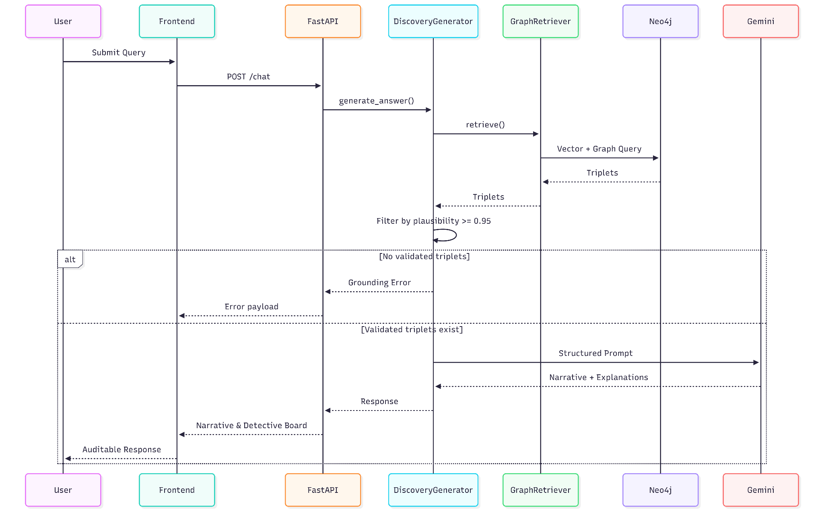

4.8 Entity-Relationship Model
To ensure complete provenance, the Neo4j schema meticulously tracks ingestion operations and structural relationships.
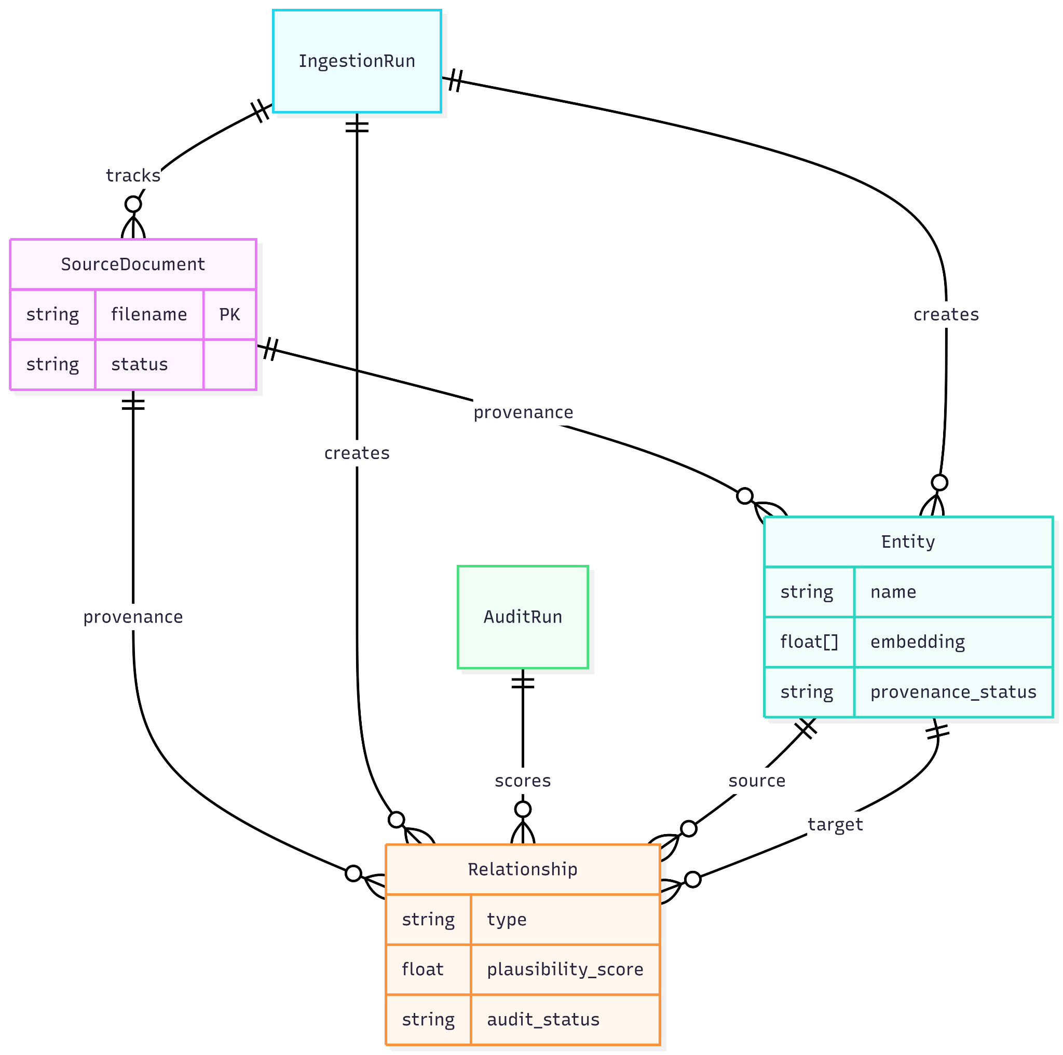

References
Athaluri, S., Manthena, S., Kesapragada, V. S. R. K., Yarlagadda, S., Dave, T., & Duddumpudi, R. T. S. (2023). Exploring the boundaries of reality: Investigating the phenomenon of artificial intelligence hallucination in scientific writing through ChatGPT references. Cureus, 15(4), e37432. https://doi.org/10.7759/cureus.37432
Borah, R., Brown, A. W., Capers, P. L., & Kaiser, K. A. (2017). Analysis of the time and workers needed to conduct systematic reviews of medical interventions using data from the PROSPERO registry. BMJ Open, 7(2), e012545. https://doi.org/10.1136/bmjopen-2016-012545
Edge, D., Trinh, H., Cheng, N., Bradley, J., Chao, A., Mody, A.,... & Larson, J. (2024). From local to global: A graph RAG approach to query-focused summarization. arXiv. https://arxiv.org/abs/2404.16130
Frohock, C. (2025). Ghosts at the gate: A call for vigilance against AI-generated case hallucinations. Penn State Law Review, 130(1). https://www.pennstatelawreview.org/print-issues/ghosts-at-the-gate-a-call-for-vigilance-against-ai-generated-case-hallucinations/
Gøtzsche, P. C., Hróbjartsson, A., Marić, K., & Tendal, B. (2007). Data extraction errors in meta-analyses that use standardized mean differences. JAMA, 298(4), 430–437. https://doi.org/10.1001/jama.298.4.430
Guo, Z., et al. (2025). How do AI agents do human work? Comparing AI and human workflows across diverse occupations. arXiv. https://arxiv.org/abs/2510.22780
He, J., et al. (2025). Data extraction error in pharmaceutical versus non-pharmaceutical interventions for evidence synthesis: Study protocol for a crossover trial. Contemporary Clinical Trials Communications, 35(10092), 101189. https://doi.org/10.1016/j.conctc.2023.101189
He, J., et al. (2025). Validity of data extraction in evidence synthesis practice of adverse events: Reproducibility study. Annals of Internal Medicine.(((https://doi.org/10.7326/ANNALS-25-00739)))
Liu, Z., et al. (2024). Financial fraud detection using graph neural networks: A systematic review. Expert Systems with Applications. https://doi.org/10.1016/j.eswa.2023.120456
Nature. (2023). Generative AI images are breaking the rules for research [Editorial]. Nature, 618, 215. https://doi.org/10.1038/d41586-023-01831-2
Phan, H. T., Nguyen, N. T., & Hwang, D. (2023). Fake news detection: A survey of graph neural network methods. Applied Soft Computing, 139, 110235. https://doi.org/10.1016/j.asoc.2023.110235
Vashishth, S., Sanyal, S., Nitin, V., & Talukdar, P. (2020). Composition-based multi-relational graph convolutional networks. International Conference on Learning Representations (ICLR). https://arxiv.org/abs/1911.03082
Xu, C., et al. (2022). Validity of data extraction in evidence synthesis practice of adverse events: Reproducibility study. BMJ, 377, e069155. https://doi.org/10.1136/bmj-2021-069155
Zhang, J., Ying, R., & Shao, J. (2024/2025). Online detection of anomalies in temporal knowledge graphs with interpretability (AnoT). arXiv. https://arxiv.org/abs/2408.00872 Barry, M., Caillaut, G., Halftermeyer, P., Qader, R., Mouayad,
M., Le Deit, F., & Cariolaro, D. (2025). GraphRAG: Leveraging graph-based efficiency to minimize hallucinations in LLM-driven RAG for finance data. ACL Anthology. https://aclanthology.org/2025.genaik-1.6/
Zhang, J., Ying, R., & Shao, J. (2024). Online detection of anomalies in temporal knowledge graphs with interpretability (AnoT). arXiv. https://arxiv.org/abs/2408.00872

